System Requirements
Specifications and Technical Design

Introduction

This document presents the System Requirements Specification (SRS) and Technical Design for the proposed DIBA Bookings Campus Venue and Event Management System. The purpose of the document is to define the requirements, functionality, technical structure, and design of the proposed system based on the problem domain and objectives identified in the business case.

The document describes the functional and non-functional requirements of the system, including the requirements for users, venues, events, bookings, availability, administration, and notifications. It also defines the system's technical design, including its architecture, database structure, user interfaces, system processes, and security considerations.

The document will provide the foundation for the development of the system by translating the identified business needs into clear, implementable system requirements and technical specifications. Where requirements have not yet been confirmed by Conference Centre stakeholders, they will be treated as preliminary requirements and refined as additional stakeholder information becomes available.

  - Plan to Address Objectives

The proposed system will address the identified objectives through a centralized web-based venue and event management platform. The following table outlines the main software interventions and how each will contribute to addressing the identified real-world problems.

Objective | Planned Software Intervention | How It Addresses the Objective
1. Centralise venue information | Develop a centralised web-based venue catalogue containing venue details such as capacity, location, facilities, parking and available equipment. | Organisers can access commonly requested venue information from one location without relying on repeated phone calls or emails.
2. Improve venue availability visibility | Provide venue availability information through venue status and booking conflict validation. The system checks existing Pending and Approved bookings when a booking request is created or updated to help prevent overlapping reservations for the same venue | Organisers can check venue availability before submitting a request, while authorised staff can view existing bookings in one place.
3. Streamline booking requests | Implement a digital booking form and booking workflow through which organisers can submit and monitor requests. | Replaces fragmented booking enquiries with a structured process and gives organisers visibility of their booking status.
4. Assist organisers in finding suitable venues | Implement venue search and filtering based on criteria such as capacity, facilities, location and availability. | Organisers can identify suitable alternatives instead of relying on staff to recommend available venues manually.
5. Provide centralised administration | Provide an administrative interface for authorised staff to manage venues, availability, bookings and booking requests. | Staff can manage relevant information from a central system rather than relying on separate records and communication channels.
6. Improve booking communication | Implement booking-status updates and system notifications for events such as request submission, approval, rejection or changes. | Organisers remain informed about their requests without repeatedly contacting staff for updates.
7. Reduce unnecessary enquiries | Provide self-service access to venue information, availability and booking-status information. | Users can obtain common information independently, reducing repetitive enquiries handled by administrative staff.

1.2 Project Scope

The proposed DIBA Bookings – Campus Venue and Event Management System will be a web-based system designed to support the discovery, booking, administration, and management of university event venues. The initial implementation will focus on the Nelson Mandela University Conference Centre, providing a manageable environment in which the proposed processes and functionality can be developed and evaluated.

The system will provide functionality for different categories of users, including event organisers, internal university users, and authorised Conference Centre administrators. Users will be able to access relevant venue information, search for suitable venues, view availability, submit booking requests, and monitor the progress of their requests. Administrators will have additional functionality for managing venue information, bookings, availability, and user-related activities.

The scope is divided into information, functional, and communication scope to define what information the system will manage, what activities the system will support, and how users and the system will communicate.

1.2.1 Information Scope

The information scope defines the data that the proposed system will capture, store, retrieve, update, and manage.

Venue Information

The system will maintain information about venues available through the Conference Centre. The venue information will include:
- Venue identification.
- Venue name.
- Venue description.
- Venue location.
- Maximum capacity.
- Venue status.
- Venue-specific features.

This information will allow users to evaluate venues before submitting a booking request.

User Information

The system will maintain information required to identify and manage system users. Depending on the user's role, this may include:
- User identification.
- First name.
- Last name.
- Email address.
- Phone number.
- Password hash.
- User role.
- Account status.
- Account creation information.
Different roles will have different permissions. For example, an organiser should not have the same management privileges as an administrator.

Event Information

The system will store information about events associated with venue bookings. This may include:

- Event identification.
- Event name.
- Event description.
- Event type.
- Expected event attendance.
- Start date and time.
- End date and time.
- Associated venue.
- Event organiser.
The event information will be associated with the relevant booking and organiser.

Booking Information

Booking records will contain information required to manage requests and reservations. This may include:

- Booking identification.
- Event.
- Event organiser.
- Requested venue.
- Booking date.
- Start date and time.
- End date and time.
- Special requirements.
- Booking status.
- Administrative notes.
Possible booking statuses may include Pending, Approved, Rejected, Cancelled, and Completed.

Payment Information

The system will maintain payment records associated with bookings for payment tracking purposes. Payment information will include:
- Payment identification.
- Payment amount.
- Payment date.
- Payment reference number.
- Associated booking.
The initial implementation records payment information but does not process online financial transactions or integrate with an external payment gateway.

Audit Information
The system will maintain audit records for important system activities to support accountability. Audit records will include:
- Audit log identification.
- Action performed.
- Description of the action.
- Timestamp.
- User responsible for the action.
Audit records provide an administrative history of important activities performed within the system.

Availability Information

The system will maintain information required to determine whether a venue can be requested for a particular period.

Availability will be linked to existing bookings and relevant venue restrictions. The system should prevent conflicting bookings from being created for the same venue and overlapping time period.

Notification and Communication Information

The system may store records associated with notifications and booking updates, including:

- Notification type.
- Recipient.
- Related booking.
- Date and time.
- Notification status.
- Relevant message or update.

This will allow users to remain informed about important changes to their booking requests.

Administrative Information

Authorised administrators will be able to manage information required to operate the system. This may include:

- Venue records.
- Venue availability.
- Booking requests.
- User accounts and roles.
- Event information.
- Booking statuses.
- Administrative notes.
- System-generated records required for reporting and auditing.
- Data Storage and Security

The system will use a relational database as the primary storage mechanism for structured system information. Data will be accessed through the web application rather than being maintained through separate spreadsheets, emails, or manually managed records.

Sensitive information, particularly authentication credentials, must be protected using appropriate security practices. Passwords should not be stored as plain text, and access to information should be controlled according to the user's role.

The system should also maintain sufficient records to support accountability, such as when a booking was submitted or when its status was changed.

1.2.2 Functional Scope

The functional scope describes the activities that users will be able to perform through the system.

User Registration and Authentication

The system will provide authentication functionality allowing users to securely access the platform.

Users will be assigned appropriate roles, such as:

- External organiser
- Internal university user
- Administrator

The system will use role-based access control to ensure that users can only access functionality appropriate to their responsibilities.

Venue Discovery

Users will be able to browse venues through a centralised venue catalogue. Venue profiles will provide information including venue name, description, capacity, location, venue status and associated venue features.

Venue Search and Filtering

The system will provide search and filtering functionality to help organisers identify appropriate venues.

Users may be able to filter venues according to criteria such as:

- Required capacity
- Event date
- Availability
- Location
- Accessibility requirements

This will also allow the system to suggest or display alternative venues when a preferred venue is unavailable.

Availability Management

Users will be able to view venue availability through a calendar or similar scheduling interface. The system will use existing booking information to determine whether a venue is available for a requested date and time. Administrators will be able to update availability where necessary, particularly where a venue is unavailable for reasons that are not represented by a normal booking.

Event Creation and Management

Organisers will be able to create an event associated with a venue booking. The event-management functionality will allow organisers to provide information such as the event name, date, time, expected attendance, event type, and venue requirements. Organisers should also be able to view and update relevant event information where changes are permitted.

Booking Request

The system will provide a structured booking process.

An organiser will be able to:

- Search for a suitable venue.
- View its information.
- Check its availability.
- Select a date and time.
- Provide event information.
- Submit a booking request.
- Receive confirmation that the request has been submitted.
- Monitor the status of the request.

The system will record the request and make it available to authorised administrators.

Booking Approval and Management

Administrators will have functionality for reviewing booking requests.

An administrator should be able to:

- View pending requests.
- Review event and organiser information.
- Check venue availability.
- Approve requests.
- Reject requests.
- Cancel bookings where appropriate.
- Add relevant comments.
- Update booking status.

The system should help prevent conflicting reservations by checking existing bookings before a request is approved.

Booking Status Tracking

Organisers will be able to monitor the progress of their requests without repeatedly contacting the Conference Centre.

The system will display the current status of each booking, such as:

Pending → Approved / Rejected → Completed or Cancelled

Where appropriate, the system will also provide information explaining changes to a request.

Administrative Dashboard

Administrators will have access to a central dashboard providing an overview of relevant activities.

The dashboard may include:

- Pending booking requests.
- Upcoming events.
- Current bookings.
- Venue availability.
- Recently submitted requests.
- Booking statistics.
- Alerts or notifications requiring attention.

The dashboard will provide administrators with a consolidated view of the booking process.

Venue Management

Administrators will be able to create, update, and manage venue records.

This includes maintaining information such as capacity, facilities, equipment, images, and availability.

This functionality is important because venue information may change over time and should be maintained from a central location.

Notifications

The system will provide notifications for important booking events.

Examples include:

- Booking request submitted.
- Booking approved.
- Booking rejected.
- Booking cancelled.
- Booking details changed.
- Other important administrative updates.

Notifications may initially be provided through the web application, with email notifications considered where technically feasible.

Reporting

The system will provide basic reporting functionality to assist administrators in understanding venue and booking activity.

Possible reports include:

- Upcoming bookings.
- Bookings by venue.
- Bookings by date.
- Booking status summaries.
- Venue utilisation.
- Event activity over a selected period.

Reporting functionality will remain focused on information useful for managing the Conference Centre rather than attempting to provide extensive business intelligence functionality.

Help and Guidance

The system will provide basic guidance to users on how to navigate the booking process.

This may include:

- Booking instructions.
- Explanation of booking statuses.
- Frequently asked questions.
- Information about required booking details.
- Contact information for relevant administrative support.
- Location-Related Functionality

Where appropriate, the system may provide location-related information to help organisers identify where venues are situated.

This could include:

- Venue location information.
- Campus location.
- Parking information.
- Map-based representation.

The exact implementation of location functionality will depend on the final technical requirements and available resources.

Security and Access Control

The application will include appropriate security controls, including:

- User authentication.
- Role-based authorisation.
- Protected administrative functions.
- Secure handling of passwords.
- Input validation.
- Session management.
- Protection against unauthorised access.

Security will be considered throughout development rather than being added only after the system has been completed.

Testing and Error Handling

The system will include validation and error-handling mechanisms to prevent invalid information from being submitted.

For example, the system should identify:

- Missing required information.
- Invalid dates or times.
- Invalid user information.
- Booking conflicts.
- Unauthorised access attempts.

The completed system will also be tested against defined test cases to determine whether its main functions operate as intended.

1.2.3 Communication Scope

The communication scope describes how users will interact with the system and how information will be communicated between the application, users, and administrators.

Web-Based Access

DIBA Bookings will be developed as a web-based application. Users will access the system through a modern web browser rather than requiring a dedicated desktop application.

This approach allows the system to be accessed from computers and other suitable internet-connected devices without requiring users to install specialised software.

User-to-System Communication

Users will communicate with the system through web interfaces.

Examples include:

- Login forms.
- Venue search interfaces.
- Venue information pages.
- Availability calendars.
- Booking forms.
- Event-management interfaces.
- Booking-status pages.
- Administrative dashboards.

Information entered by users will be transmitted to the application and stored in the system database where appropriate.

System-to-User Communication

The system will communicate important information to users through:

- On-screen confirmations.
- Booking status indicators.
- Notifications.
- Validation messages.
- Error messages.
- Administrative updates.

For example, after submitting a booking request, the organiser should receive confirmation that the request has been successfully recorded.

Booking Notifications

The system should notify organisers when important changes occur to their booking.

For example:

Booking request submitted → Pending

and later:

Booking request approved → Approved

The initial implementation will prioritise in-system notifications. Email notifications may be incorporated if they are practical within the available development environment.

Administrator Communication

Administrators will interact with the system through their administrative interface.

When a booking request is submitted, the relevant information will become available to authorised administrators. Administrators will then be able to review the request and update its status.

This reduces the need for the booking process to depend entirely on separate telephone calls or email conversations.

Internet Connectivity

Because the system is web-based, users will require network connectivity to access the application and retrieve current information.

The system is not initially intended to provide an offline booking mode. This is appropriate because venue availability needs to be based on centrally managed information. Allowing bookings to be created offline could introduce conflicts when multiple users attempt to reserve the same venue.

Communication with External Services

The initial system will primarily communicate between the web application and its database.

Where required, external services may be incorporated for specific functionality, such as:

- Email notification services.
- Mapping/location services.
- Authentication services.

Any external service integration will be considered according to project requirements, technical feasibility, security, and available development time.

Scope Boundaries

To prevent the project from becoming unnecessarily large, the following boundaries should also be established.

Included

The initial system will include:

- Conference Centre venue management.
- Venue information.
- Venue search and filtering.
- Availability viewing.
- Event creation.
- Booking requests.
- Booking approval.
- Booking-status tracking.
- User authentication.
- Role-based access.
- Administrative management.
- Basic notifications.
- Basic reporting.
- Venue/location information.
- Security and validation.
- Payment record tracking.
- Audit logging.

Outside the Initial Scope

The following will not form part of the core implementation unless additional requirements or development time make them feasible:

- Online financial transaction processing
- Integration with external payment gateways
- Online invoicing
- Catering management
- Full security-service management
- Complex procurement processes
- Advanced AI-based venue recommendations
- Dedicated Android/iOS applications
- Offline booking
- Integration with every existing NMU system
- Enterprise-level reporting and analytics

Scope Summary

In summary, the project will focus on creating a centralised web-based platform for discovering, requesting, approving, and managing Conference Centre venues and events. The information scope defines the data required to support these activities, the functional scope defines the services provided by the application, and the communication scope defines how users, administrators, and supporting services interact with the system.

1.3 Business requirements

The business requirements describe the needs and expectations of the main users of the proposed DIBA Bookings system. The requirements are based on the problem identified in the business case, research into related venue-management systems, and the intended functionality of the proposed solution. Detailed functional and non-functional requirements will be specified later in the project.

1.3.1 Event Organisers

Event organisers require a system that makes it easy to identify and request a suitable venue without relying primarily on telephone calls or email communication.
The system should:
- Provide accessible and up-to-date venue information, including capacity, location, facilities, parking and available equipment.
- Allow organisers to search and filter venues according to their event requirements.
- Allow organisers to view venue availability before submitting a booking request.
- Provide information about alternative venues when a preferred venue is unavailable.
- Provide a simple and structured booking process for submitting event and venue requirements.
- Allow organisers to view their submitted booking requests and their current status.
- Provide clear notifications when a booking is submitted, approved, rejected, cancelled, or otherwise updated.
- Reduce the need to contact Conference Centre staff for information that can be obtained directly through the system.
- Provide a clear and easy-to-use interface that does not require specialised technical knowledge.

1.3.2 Internal University Users

Internal users, including university departments, staff members and student organisations, require a consistent method of finding and requesting venues for university-related activities.
The system should:
- Allow users to access relevant venue information.
- Allow users to search for venues based on event requirements.
- Provide visibility of venue availability.
- Allow users to submit booking requests digitally.
- Allow users to monitor the progress of their requests.
- Provide relevant booking notifications and updates.
- Apply appropriate access permissions according to the user's role.
- Reduce unnecessary communication with Conference Centre staff.
- Provide a consistent booking experience rather than requiring users to rely on different processes or communication channels.

1.3.3 Conference Centre Staff

Conference Centre administrators require a centralised system for managing venue information and booking requests.
The system should:
- Allow staff to access venue information.
- Allow staff to manage venue records and venue features.
- Allow staff to view booking requests.
- Allow staff to review booking information.
- Allow staff to approve or reject booking requests.
- Allow staff to cancel bookings where appropriate.
- Allow staff to view payment records.
- Allow staff to access relevant audit information.
- Apply role-based permissions to staff functions.

1.3.4 System Administrators

System Administrators are responsible for broader system administration and authorised administrative functions.
The system should:
- Provide access to booking management.
- Allow administrators to manage venue information.
- Allow administrators to manage venue features.
- Allow administrators to review booking requests.
- Allow administrators to approve, reject and cancel bookings where appropriate.
- Allow administrators to provide rejection reasons and administrative notes.
- Allow administrators to view payment records.
- Provide access to audit logs.
- Support role-based access control.
- Provide information required to monitor system activity.

1.3.5 Common Business Requirements

In addition to the needs of individual user groups, the system should satisfy several requirements that apply across the booking process.
The system should:
- Provide a central source of venue and booking information.
- Ensure that users receive consistent information about venues and their availability.
- Prevent or minimise double-booking of venues.
- Protect information through appropriate authentication and role-based access.
- Provide reliable access through a web browser.
- Validate information entered during the booking process.
- Maintain accurate booking statuses.
- Provide sufficient information to support communication between organisers and administrators.
- Be sufficiently simple to allow users to complete common tasks without extensive training.

Business Requirements Summary
User group | Primary business needs
Event organisers | Find suitable venues, view availability, submit bookings, monitor requests and receive updates.
Internal university users
Conference Centre administrators | Manage venues, review and process bookings, maintain availability, prevent conflicts and monitor activity.
All users | Access accurate information through a centralised, secure and easy-to-use web-based system.

1.4 Hardware and Software Requirements

The DIBA Bookings system will be developed as a web-based application. The following hardware and software will be required for development, testing, hosting, and use of the system.

1.4.1 Software Requirements

- Microsoft Visual Studio will be used as one of the primary development environments for the backend and .NET components of the system.
- ASP.NET Core will be used to develop the server-side application and API functionality.
- React will be used to develop the web-based user interface.
- Microsoft SQL Server will be used as the relational database for storing users, venues, events, bookings, availability and other system information.
- Entity Framework Core may be used to facilitate communication between the ASP.NET application and the database.
- Git and GitHub will be used for source-code version control, collaboration and backup of the project source code.
- Google Chrome will be the primary browser used during development and testing, although the completed system should be accessible through other modern web browsers.
- Figma may be used for designing and refining the user interface and creating prototypes before implementation.

User Software Requirements
Users will require:
- A modern web browser such as Google Chrome, Microsoft Edge, Mozilla Firefox, or Safari.
- An active internet or network connection to access the web-based system.
- No dedicated application installation will be required on the user's device.

1.4.2 Hardware Requirements

Development Hardware

The development team will require computers capable of running the development tools and local application environment. Each development computer should have at minimum:
- A modern multi-core processor.
- 8 GB RAM or more, with 16 GB recommended for comfortable development.
- Sufficient storage for the development environment, source code and database.
- A stable internet connection.
- A display capable of comfortably working with the development environment and browser simultaneously.

User Hardware
Because DIBA Bookings is web-based, users will not require specialised hardware.
The system may be accessed using:
- Desktop computers.
- Laptop computers.
- Tablets.
- Other suitable devices capable of running a modern web browser.

Users will require a stable network or internet connection when accessing the system.

Hosting Hardware

The completed application will require a server or suitable cloud-hosting environment capable of running:
- The ASP.NET application/API.
- The React web application.
- The Microsoft SQL Server database.

The exact server specifications will depend on the final deployment environment, expected number of users, database size and available hosting resources. These requirements can therefore be refined during the deployment phase.

Development vs User Requirements
Requirement | Development Team | System Users
Computer/device | Development computer | PC, laptop, tablet or suitable device
Operating system | Windows recommended for the selected development tools | Any OS supporting a modern browser
RAM | 8 GB minimum; 16 GB recommended | No specialised requirement
Browser | Chrome/Edge for testing | Modern web browser
Internet | Required for development, GitHub and external services | Required to access the system
Software installation | Visual Studio, .NET, React/Node.js, SQL Server and supporting tools | No application installation required
Database | Local SQL Server during development | Accessed through the web application
Version control | Git/GitHub | Not required

1.5 Design constraints

The development of DIBA Bookings will be subject to several constraints that may influence the design, implementation, and deployment of the system. The main constraints relate to security, the user interface, system performance, and the project's limited development time and resources.

1.5.1 Security Constraints

DIBA Bookings will store information relating to users, events and venue bookings. Although the system is not expected to manage highly sensitive medical or financial information, unauthorised access could still expose personal information or allow users to modify bookings incorrectly.

The following security constraints will therefore apply:
- Users must authenticate before accessing functions that require an account.
- Role-based access control must restrict administrative functions to authorised users.
- User passwords must not be stored as plain text and should be securely hashed.
- Communication between the browser and server should use HTTPS when the system is deployed.
- Users should only be able to access or modify information appropriate to their role.
- Administrative functions must not be accessible to ordinary organisers.
- The system must validate user input to reduce the risk of malicious or invalid data being submitted.
- Booking information must be protected against unauthorised modification.
- Database access should be restricted to the application and authorised development/administrative users.
- Authentication sessions should be managed securely.
- Development code and database credentials must not be exposed through the public source-code repository.
- The system should maintain appropriate records of important administrative actions where required.

Security must be considered throughout development rather than being treated as a feature added at the end of the project.

1.5.2 Interface Constraints

The system will be used by different types of users with potentially different levels of technical experience. The interface must therefore be simple, consistent and easy to understand.

The following interface constraints will apply:
- The system must provide a clear and intuitive user interface for finding venues and submitting bookings.
- Venue information should be presented in a manner that allows users to compare venues easily.
- The booking process should avoid unnecessary steps and confusing forms.
- Important information such as venue availability and booking status should be clearly visible.
- The system should provide clear feedback when an action is successful or unsuccessful.
- Forms should clearly identify required information and provide understandable validation messages.
- The interface should be responsive, allowing the system to be used on desktop computers, laptops, tablets and suitable mobile devices.
- The interface should maintain a consistent navigation structure across the system.
- Administrative interfaces may contain more functionality than organiser interfaces but should remain understandable and organised.
- Accessibility should be considered when selecting interface elements, text sizes, labels and colour combinations.
The design should also avoid unnecessarily reproducing the complexity found in large enterprise-level venue-management systems, as the initial implementation is focused on the Conference Centre.

1.5.3 Performance Constraints

The system should provide an acceptable response time when users search for venues, view availability and submit booking requests.

The following performance constraints will apply:
- Venue searches and filtering should return results efficiently.
- Availability information should be retrieved without unnecessary delays.
- Booking requests should be processed promptly after submission.
- The system should be able to handle multiple users accessing venue and booking information without significant degradation during normal use.
- The application should avoid loading unnecessarily large amounts of data when displaying venue information.
- Images and other media used by venue profiles should be appropriately optimised to reduce loading times.
- The system should prevent duplicate or conflicting booking requests through appropriate validation and database checks.

Because the project is being developed by a two-person student team, performance optimisation will focus on the core functions of the system rather than attempting to achieve enterprise-level scalability.

1.5.4 Development and Project Constraints

The project is also subject to practical development constraints.
- The project is being developed by two students, limiting the amount of development and testing that can be completed simultaneously.
- The project has a fixed academic timeframe, requiring features to be prioritised.
- Access to detailed Conference Centre requirements may be limited because stakeholder responses have not yet been received.
- Some requirements will therefore initially be based on preliminary investigation, research and analysis of related systems and will need to be validated when stakeholder feedback becomes available.
- The system should prioritise a Minimum Viable Product (MVP) containing the core booking and venue management functionality before optional features are implemented.
- The selected technologies must be compatible with the team's available development skills, hardware and software environment.
- Integration with existing Nelson Mandela University systems is outside the initial scope unless the required access and technical information become available.

1.6 High-level use case diagram

The proposed DIBA Bookings system will support different categories of users with different responsibilities and interactions. To improve readability, the use cases are divided into three diagrams representing the Event Organiser, Conference Centre Staff, and System Administrator.

1.6.1 Event Organiser Use Case Diagram

Actor: Event Organiser
The Event Organiser interacts primarily with the system to discover suitable venues, submit and manage booking requests, and receive information about the progress of bookings.

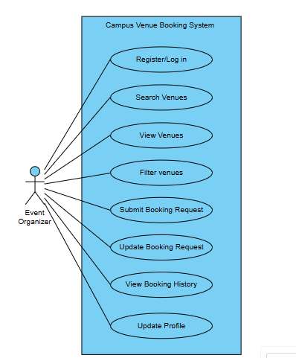
Figure 1: High-level use case diagram for the Event Organiser.

1.6.2 Conference Centre Staff Use Case Diagram

Actor: Conference Centre Staff
Conference Centre staff are responsible for managing venue information and processing booking requests. They require greater access to booking and venue-management functions than event organisers.
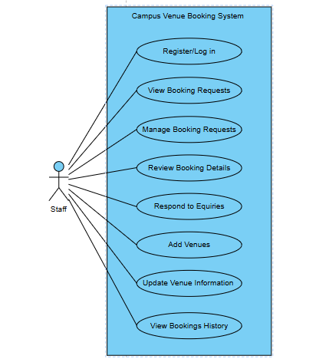
Figure 2: High-level use case diagram for Conference Centre Staff.

1.6.3 System Administrator Use Case Diagram

Actor: System Administrator
The System Administrator is responsible for managing the system itself, including users, roles, system information and administrative configuration.

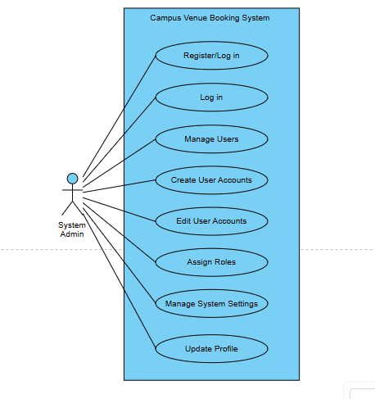
Figure 3: High-level use case diagram for the System Administrator.

1.7 UML Class Model / Diagram

The UML class diagram represents the main classes that form the DIBA Bookings system and their relationships. The model includes users, roles, venues, venue features, events, bookings, booking statuses, notifications, payments and audit logs. The associations represent how these entities interact within the application and correspond to the relationships implemented in the backend domain model.
The Role class is associated with User to support role-based access control. User is associated with events, bookings, notifications and audit logs. Venue is associated with events, bookings and venue features. Booking is associated with an event, venue, booking status, payments and notifications.
The system does not use class inheritance for user roles. Instead, Administrator, Staff and Event Organiser are represented as role values associated with the User entity.

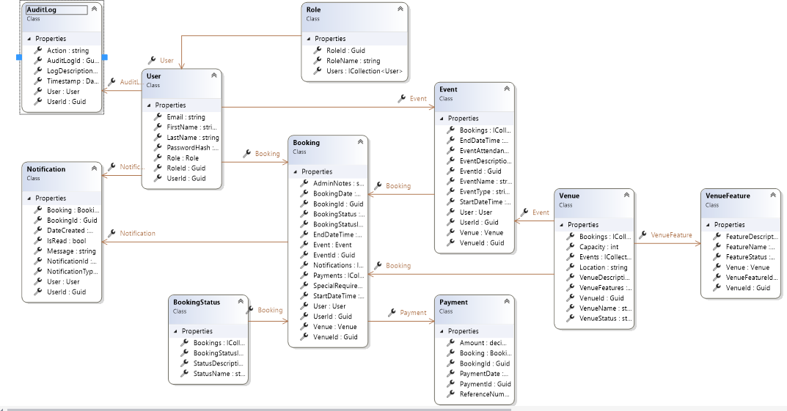
Figure 4: UML Class Model / Diagram

1.8 Relational Database Model Diagram

The relational database model represents the database structure used by the DIBA Bookings system. The database contains tables for users, roles, venues, venue features, events, bookings, booking statuses, notifications, payments and audit logs.
Primary keys uniquely identify records, while foreign keys establish relationships between related tables. The model supports the central booking workflow by linking users to their roles, events and bookings, while bookings are linked to venues, booking statuses, payments and notifications. Audit logs are linked to users to identify the user responsible for recorded actions.
The relational model is implemented using Microsoft SQL Server and accessed by the ASP.NET Core backend through Entity Framework Core.

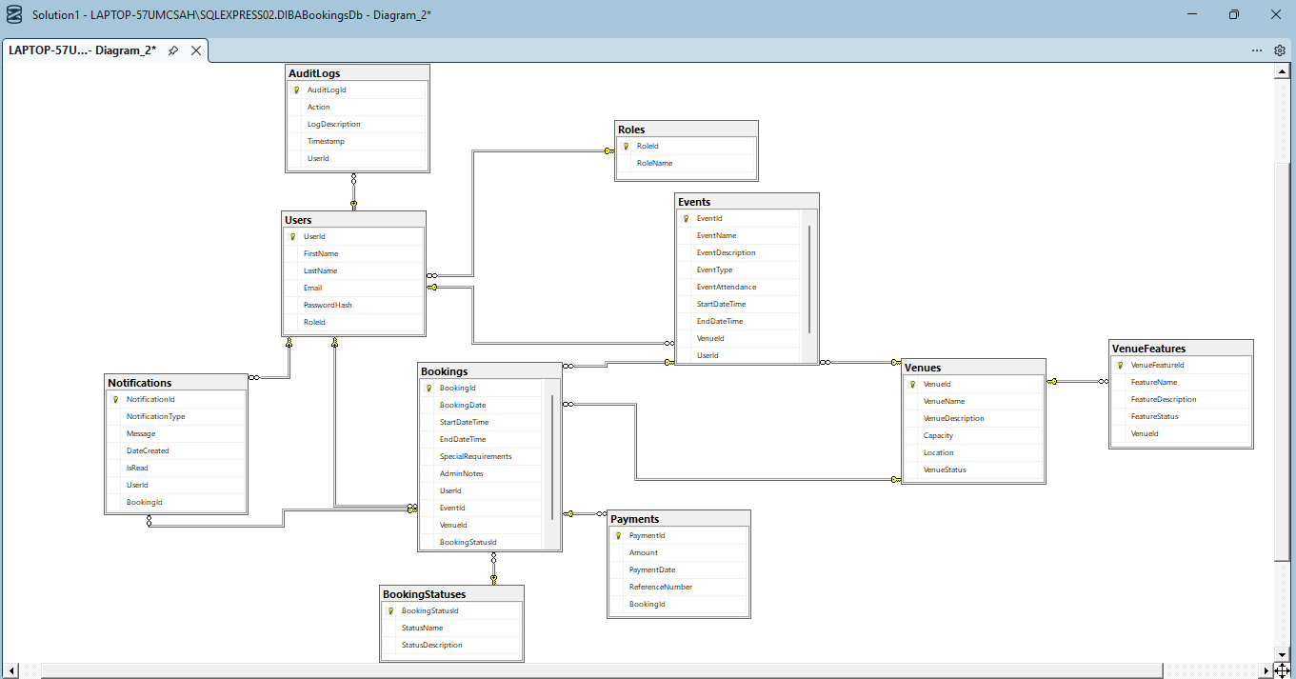
Figure 5: Relational Database Model Diagram

1.9 User Interface Design

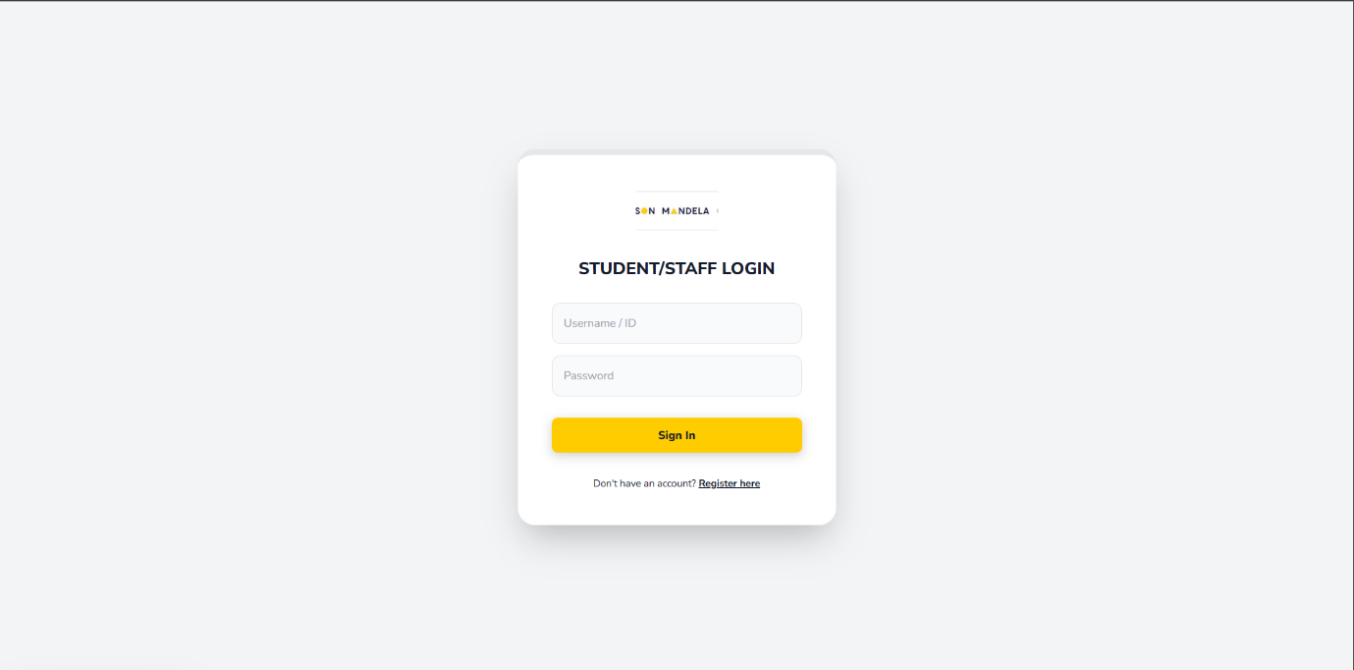
Login screen
Figure 4: Registration screen for all users of the system will be redirected to the the dashboard

Registration screen
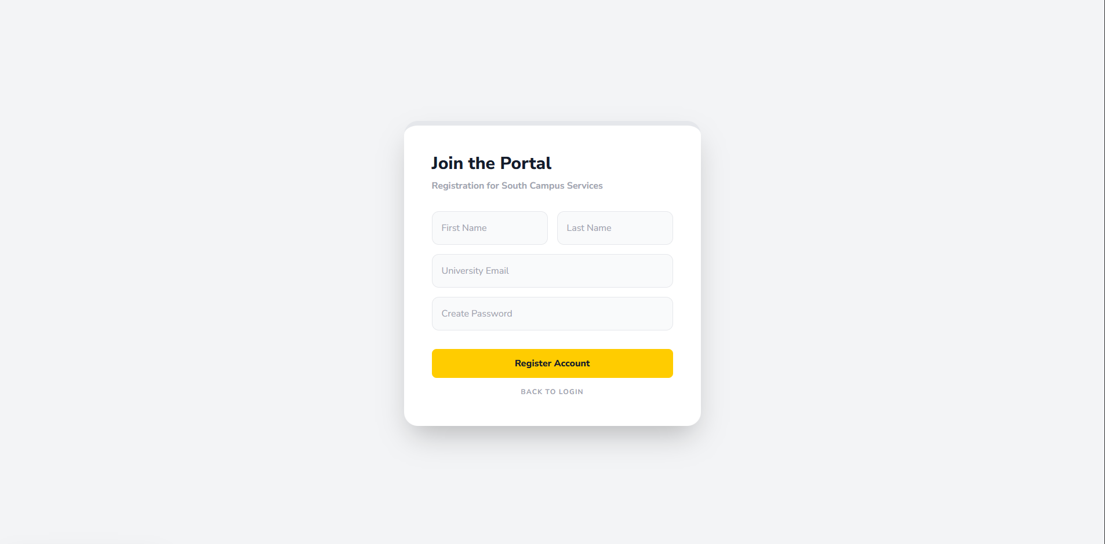
Figure 5: Registration screen for new users who will redirected to the login screen.

Event organiser

Search and view venue screen
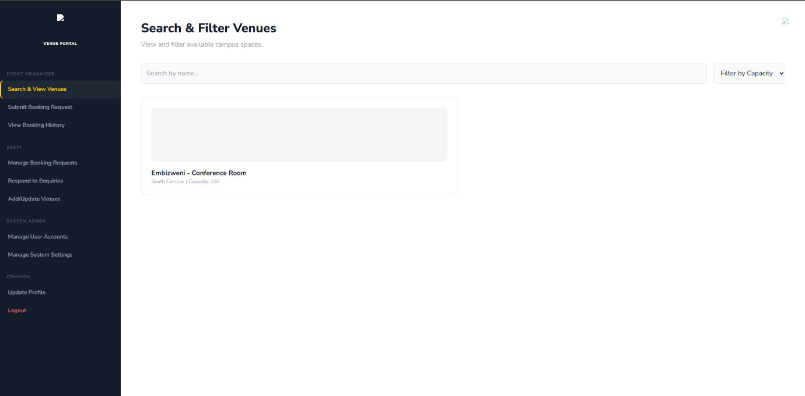
Figure 6: for the event organisers the search and view venue screen.

Submission of booking requests
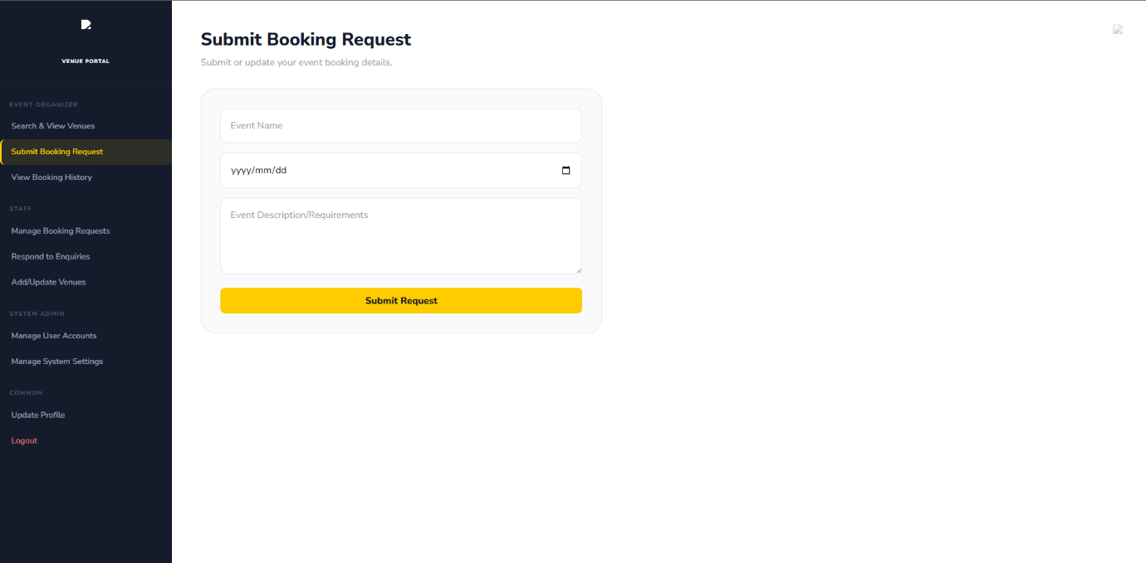
Figure 7: For the event organizer submitting the booking request that will be handled by staff.

Viewing of booking history
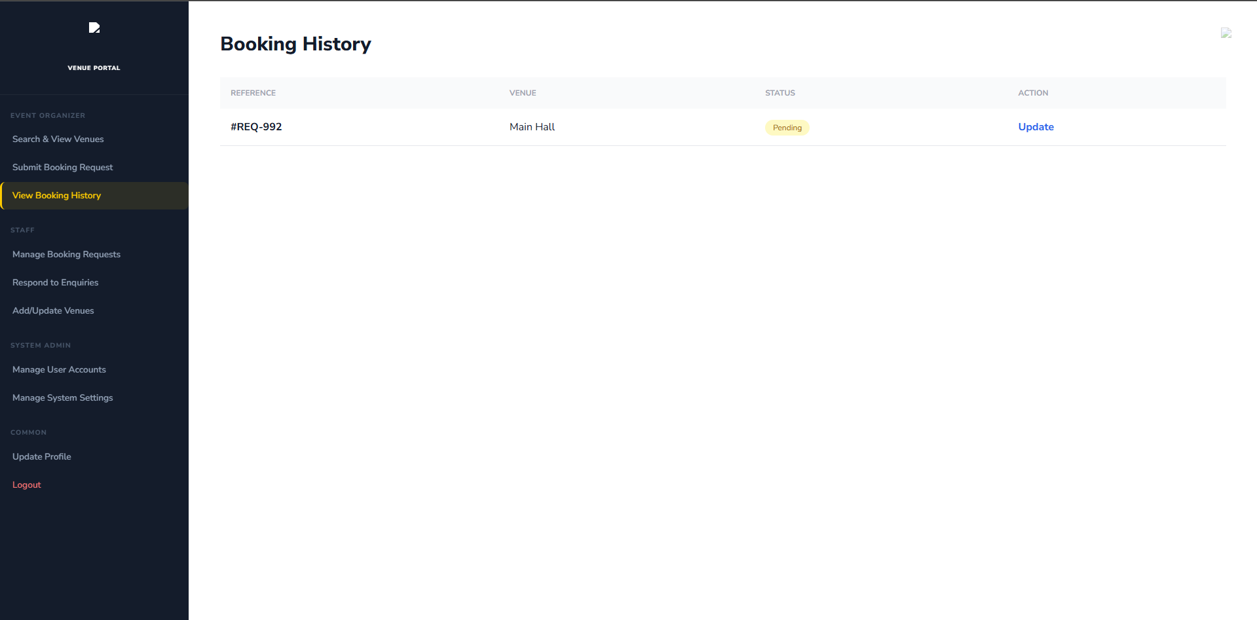
Figure 8: event organizer is also able to view to their booking history.

Staff

Managing booking requests
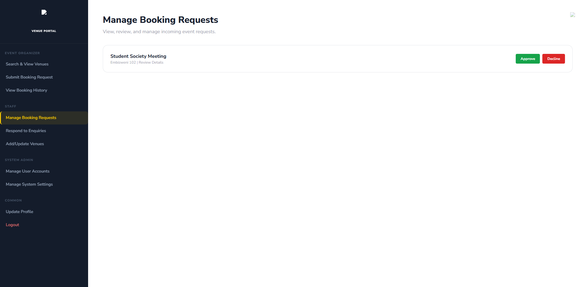
Figure 9: staff is able to manage to booking requests.

Responding to enquiries
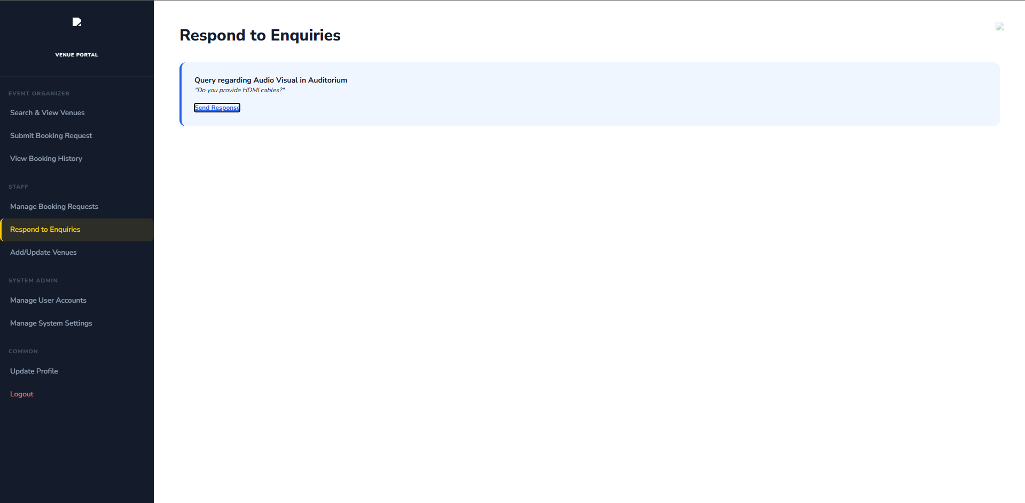
Figure 10: being able to respond to enquiries is an important feature for staff too.

Adding and updating of venues
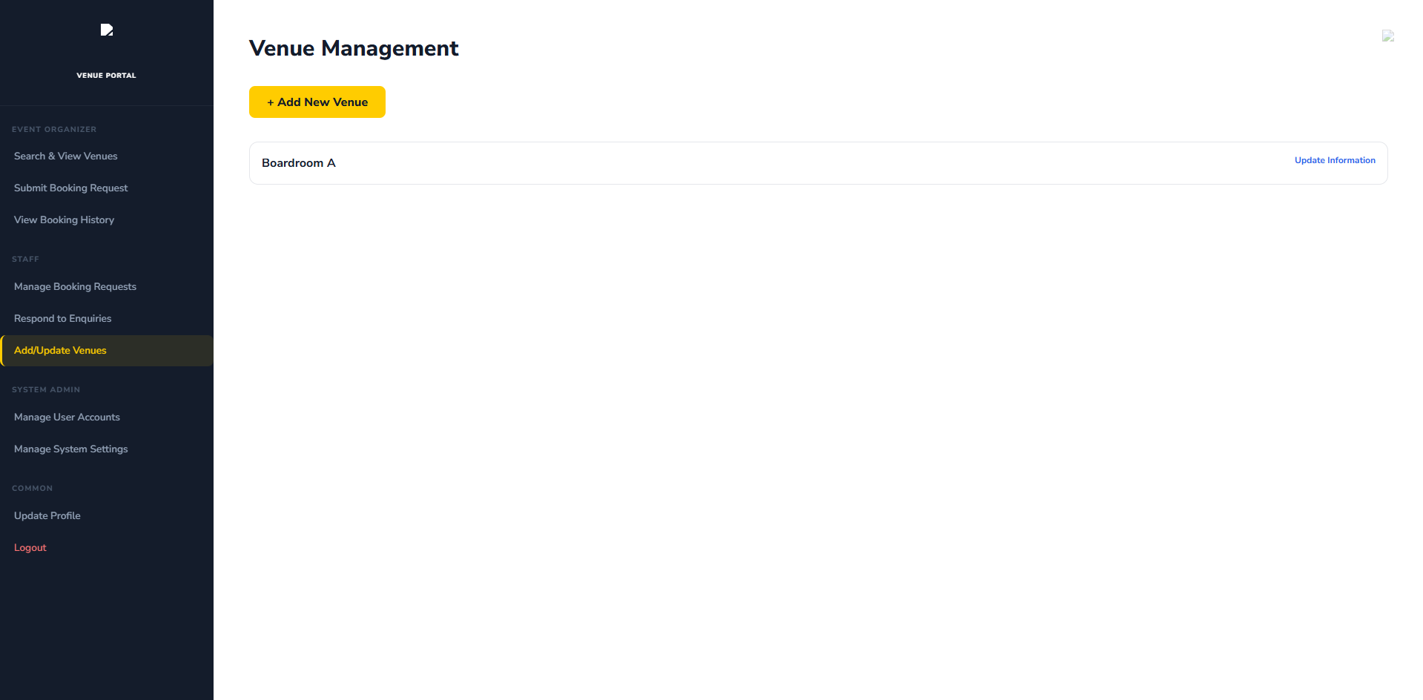
Figure 11: adding and updating of venues by staff

System admin

User account management
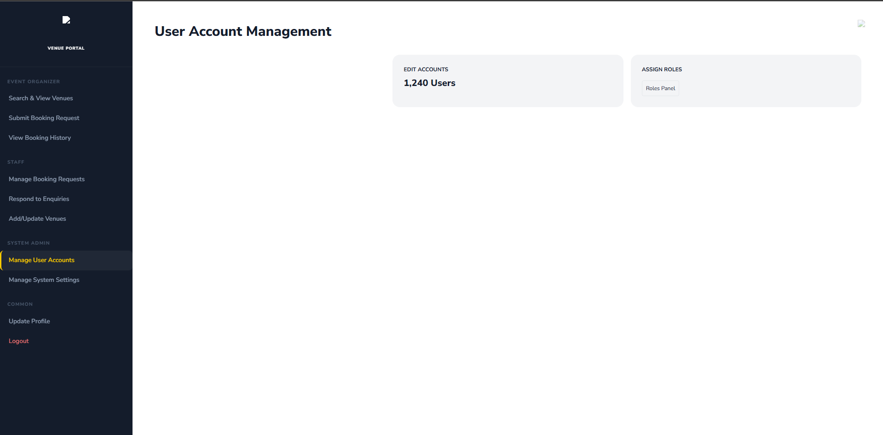
Figure 12: Managing the user accounts by system admin.

Management system settings
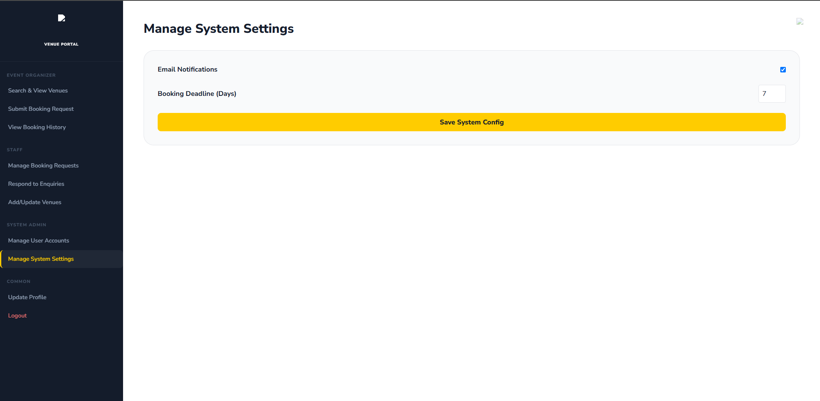
Figure 13: Managing the system setting. To add new venue that might get built in future or delete venues that have been demolished or changed.

Update Profile
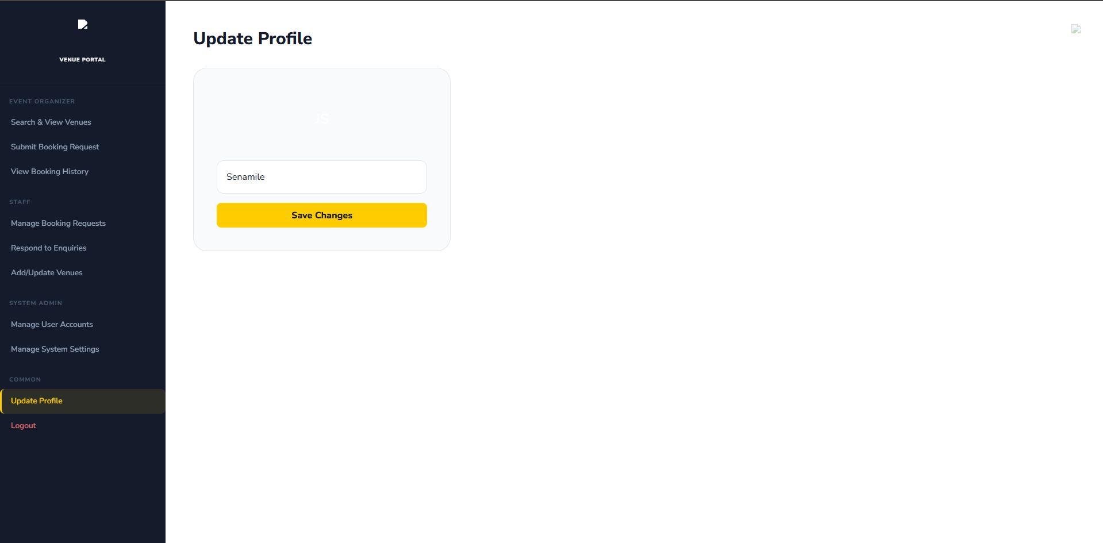
Figure 14: Common feature for all the potential user is updating of the profiles.

